**Project 1 - DEPLOYING WORDPRESS APPLICATION USING DOCKER IN AMAZON**

* **STEP 1: Creating and launching an Amazon Linux EC2 instance**
* Choosing an AMI – Amazon Linux 2 AMI

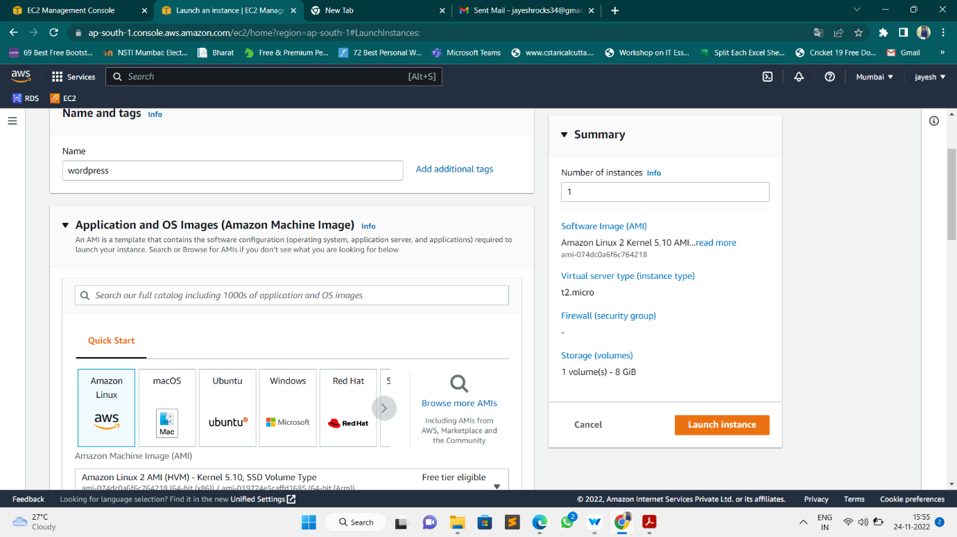

# Select an Existing keypair or create a new key pair

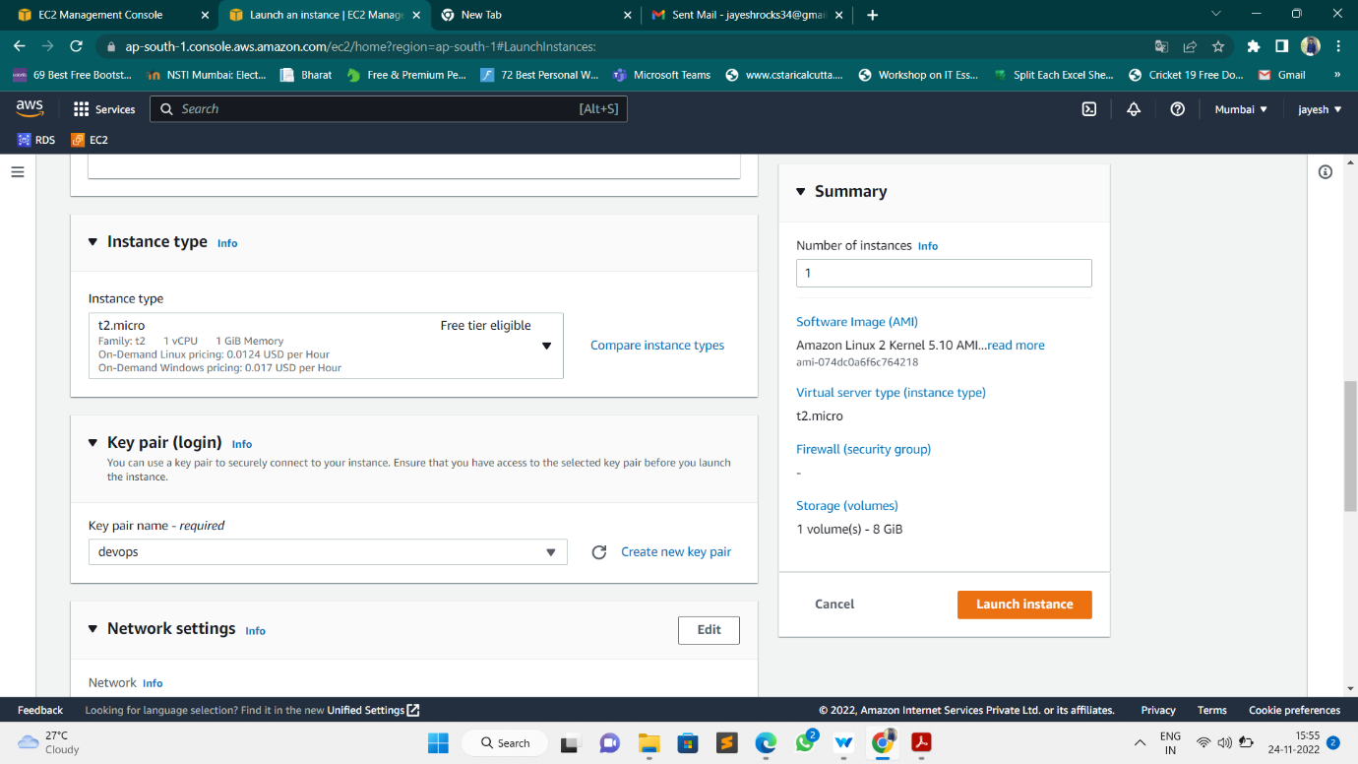

# Configure Security Group

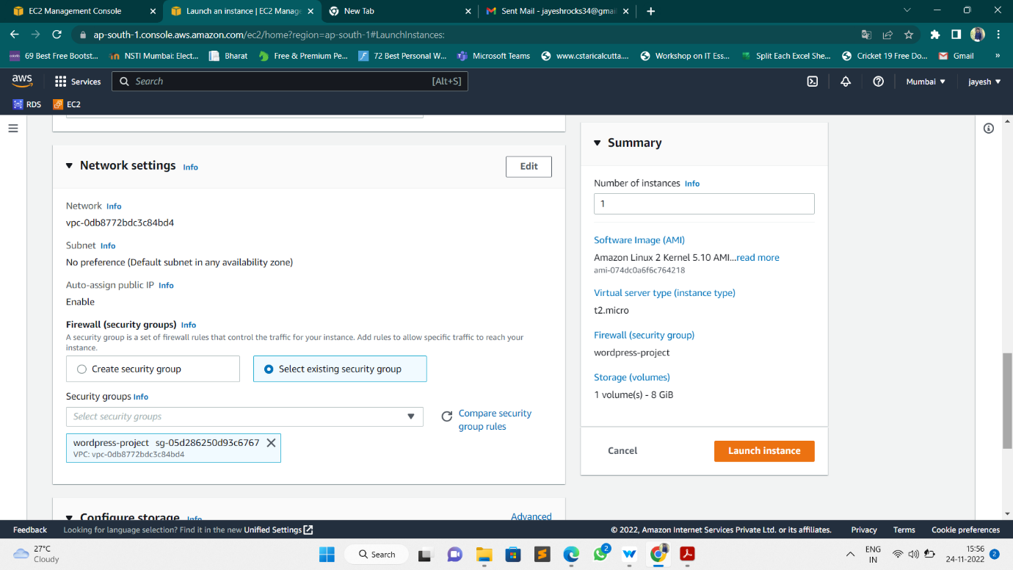

* Finally, Instance launched a WordPress Instance.

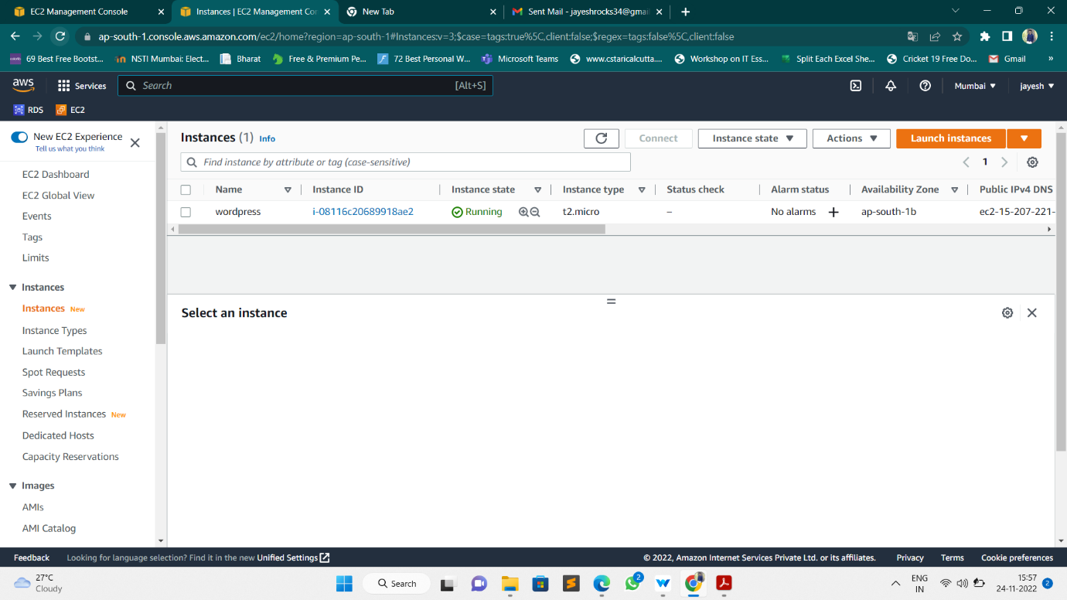

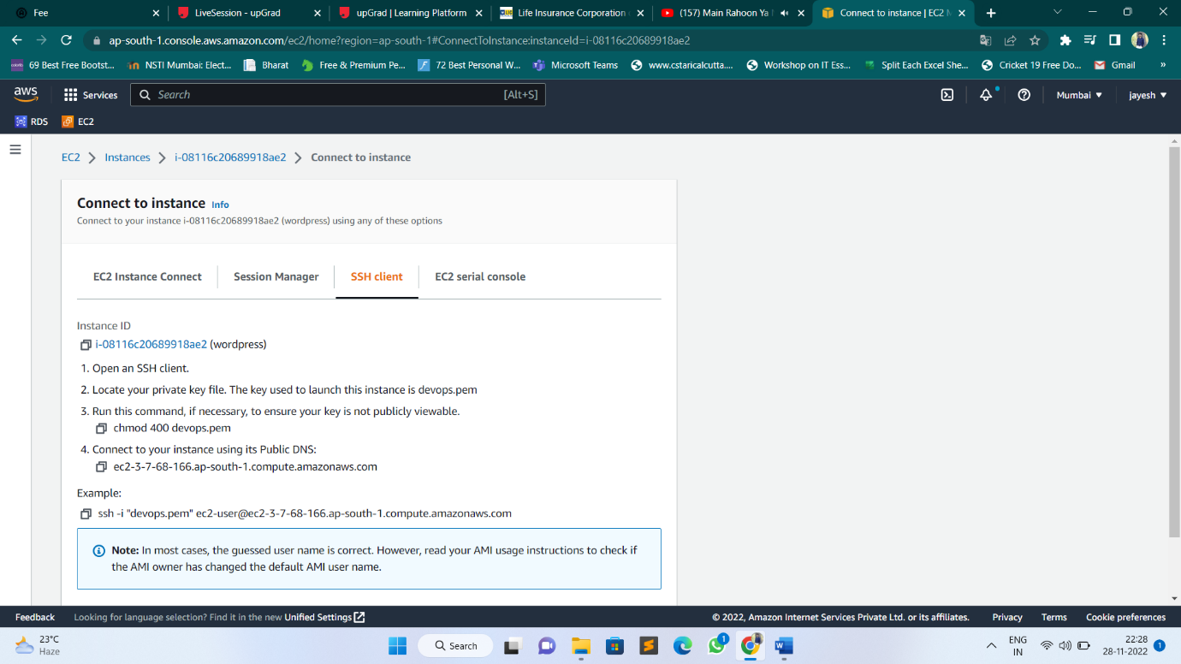

By using SSH command we are accessing our instance in Command Line Interface Terminal.

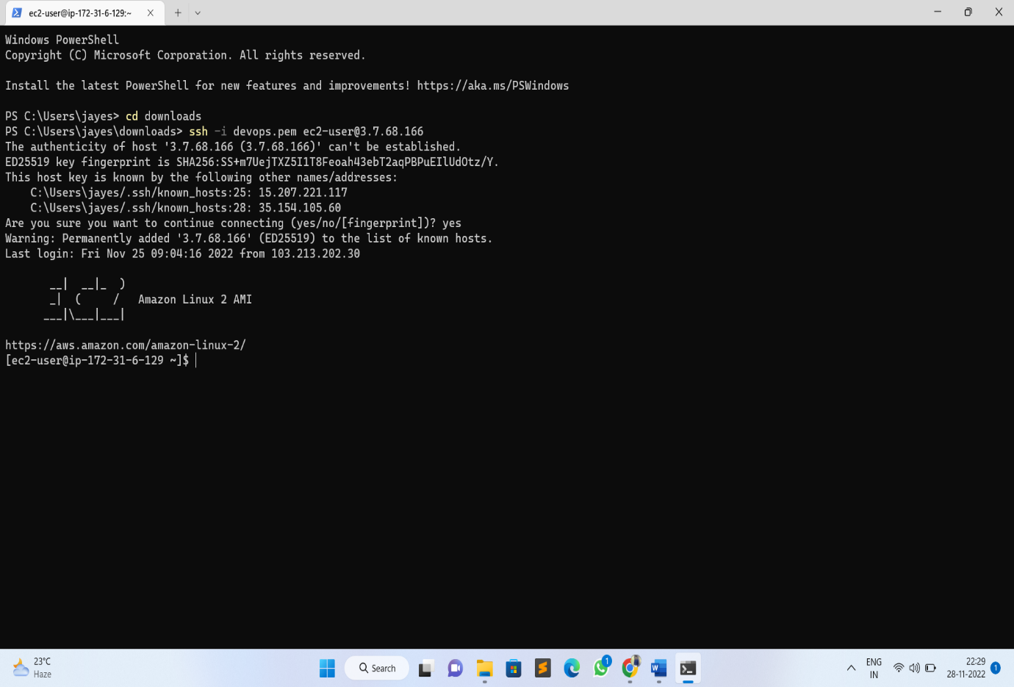

# Step – 2: Installing GIT, Docker and related repos

* Installing GIT in our instance by using below command
* Sudo yum -y install git

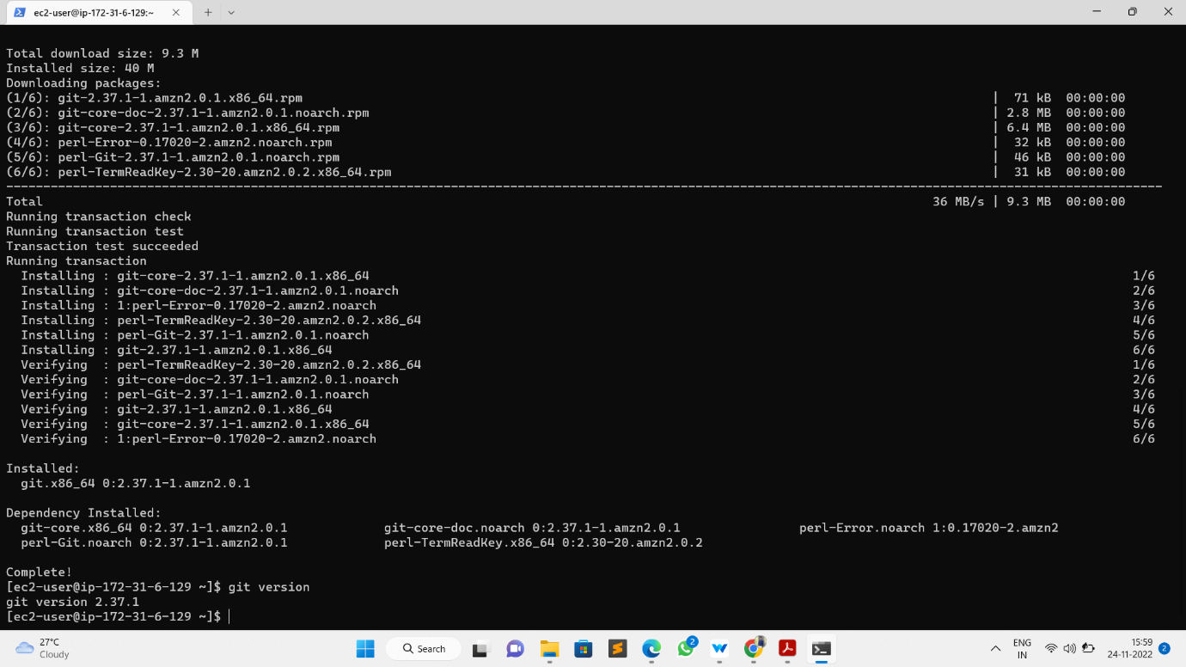

* Install docker and docker-compose and required dependencies by using below command.
* Sudo yum -y install docker

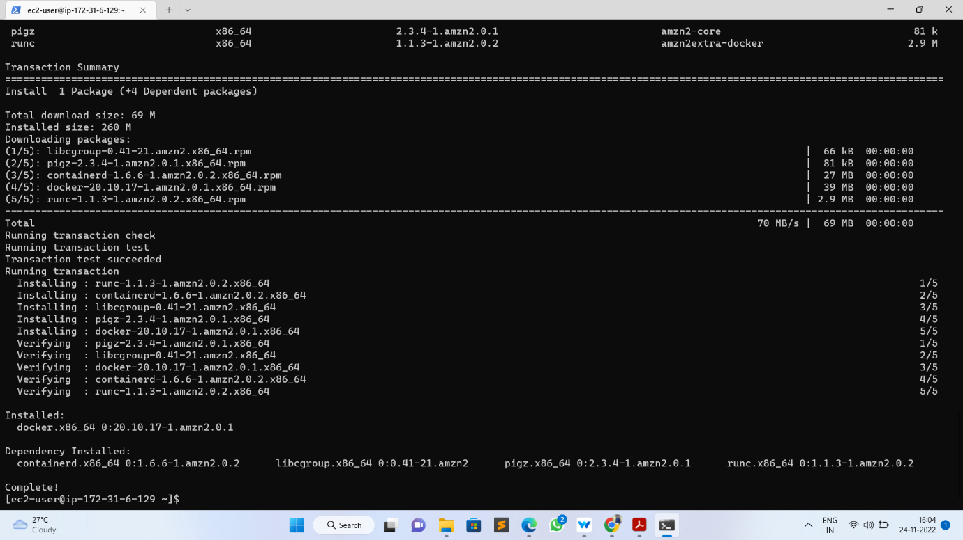

* Give the permission to add a limited Linux user account to the "docker" group by using below command
* Sudo usermod -a -G ec2-user

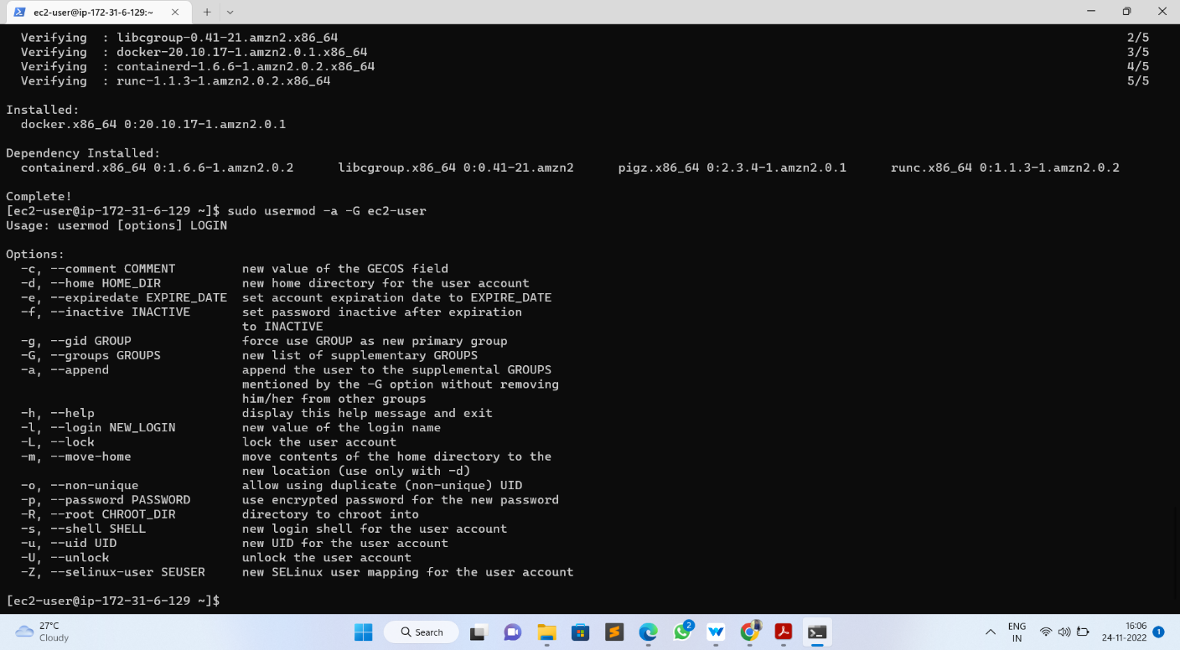

* Start docker service by using below command
* Sudo service docker start

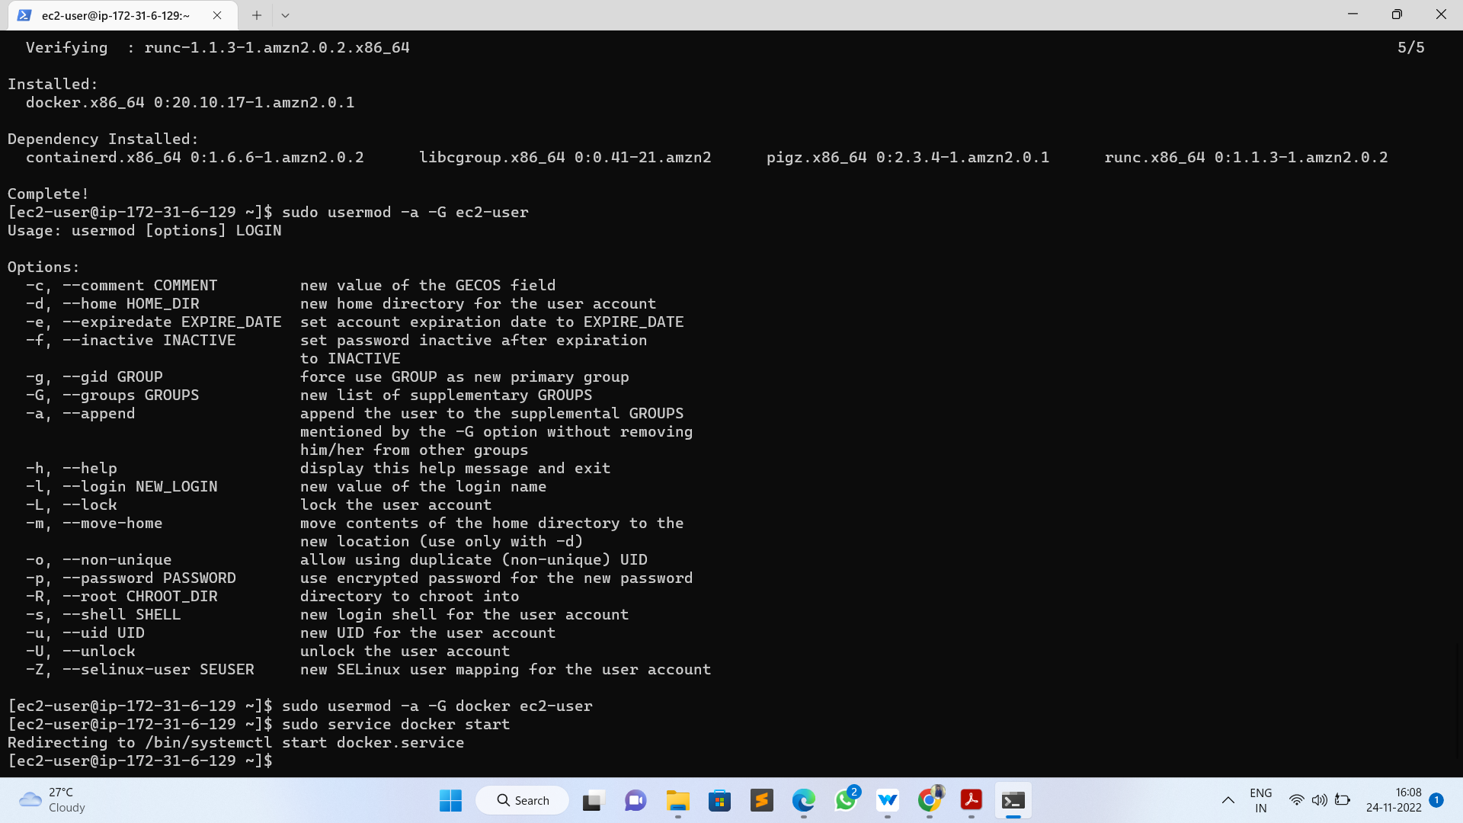

* Run below command to get docker service up automatically after reboot:
* Sudo chkconfig docker on

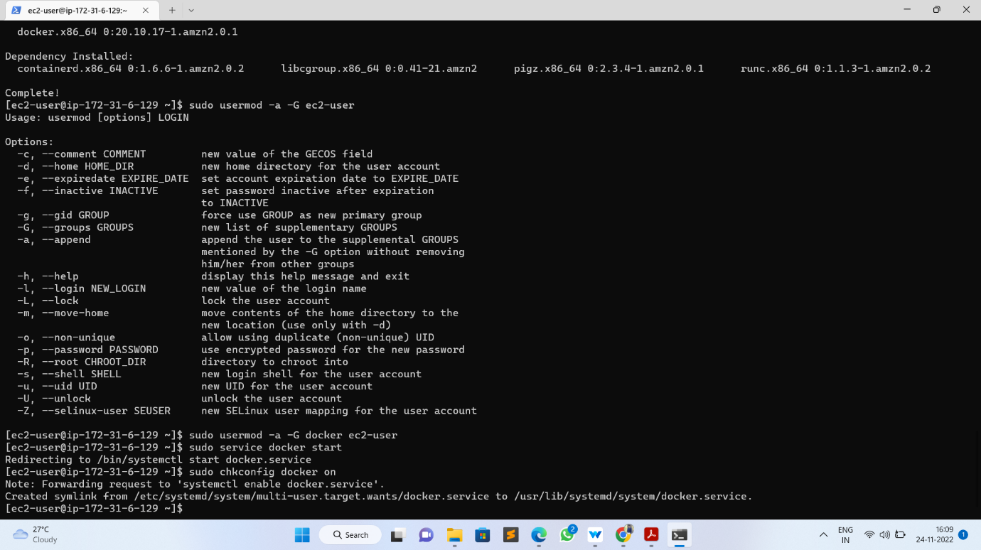

# Install Docker Compose

* Download the latest version of Docker Compose (Install Docker Compose). Run this command to download the current stable release of Docker Compose by using below command
* sudo curl -L https://github.com/docker/compose/releases/download/1.22.0/docker-compose-$(uname -s)-$(uname -m) -o /usr/local/bin/docker-compose

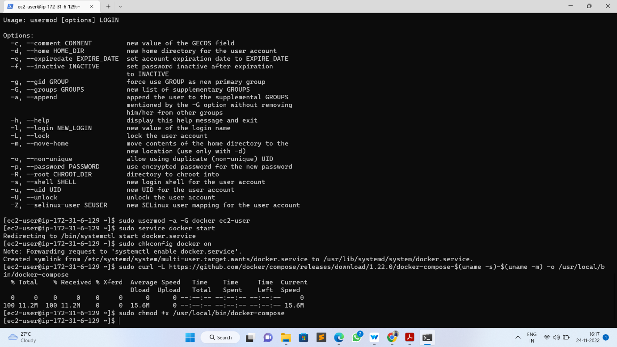

* Apply executable permissions to the binary:
* sudo chmod +x /usr/local/bin/docker-compose

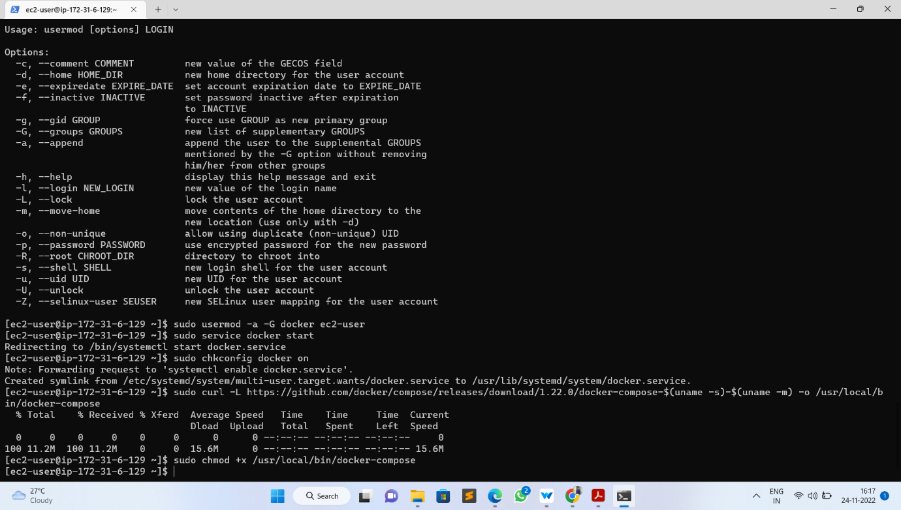

* Create a symbolic link
* ln -s /usr/local/bin/docker-compose /usr/bin/docker-compose

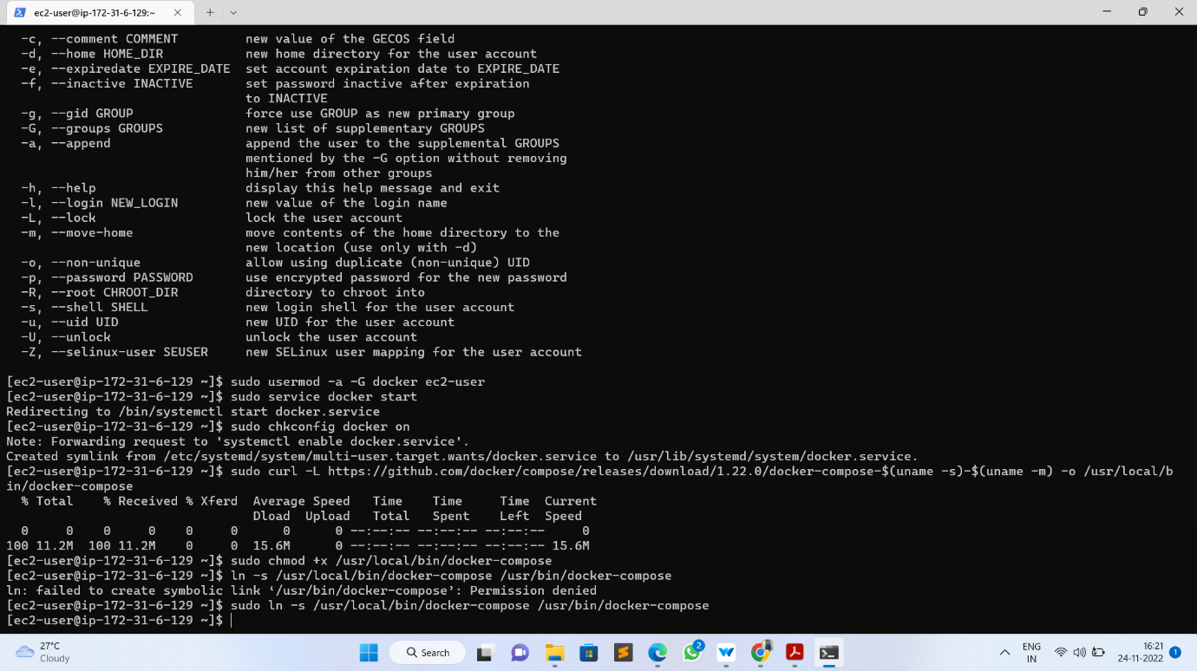

* Check installed docker-compose version
* docker-compose –version

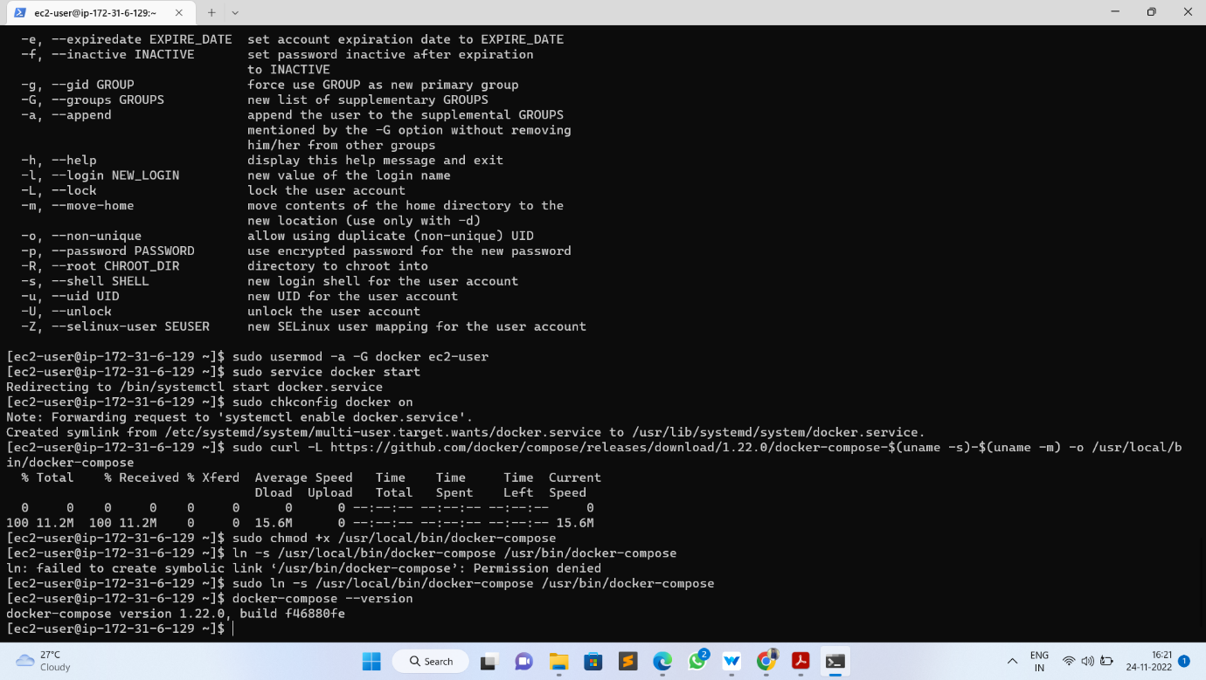

* **Step 3: Creating WordPress setup for Docker images with help of YAML scripting**
* Here, we have to create docker-compose.yaml file to pull images from docker hub:
* Sudo docker-compose.yml

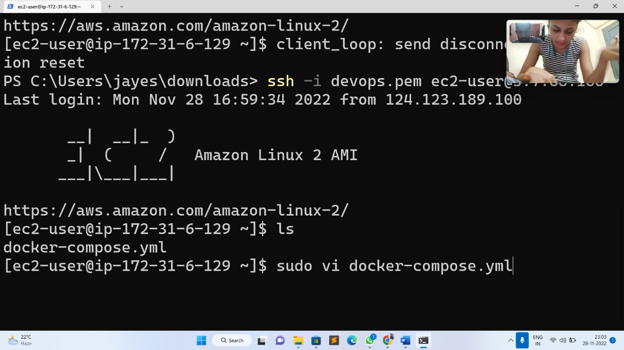

* Here is our docker-compose.yaml file:

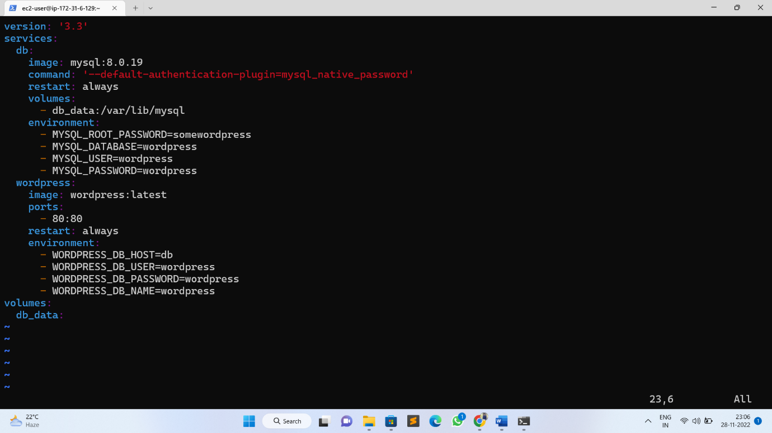

* Initially I had a go at running this locally on with Docker Compose:
* Sudo docker-compose up -d
* By using docker-compose.yaml file it was pulling images are **MySQL** and **WordPress**.

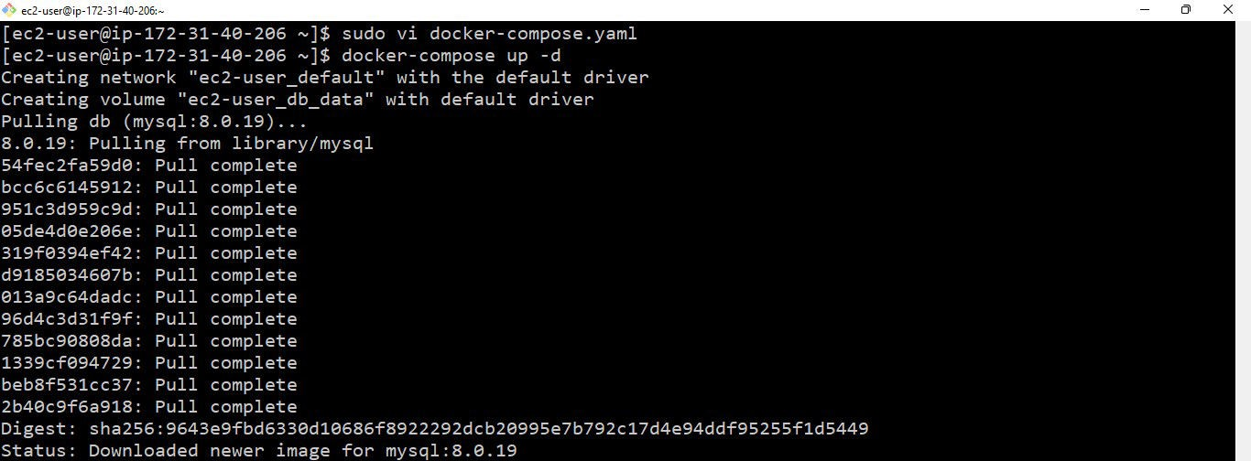

* Then I can get the list of running containers by using below command
* Sudo docker ps

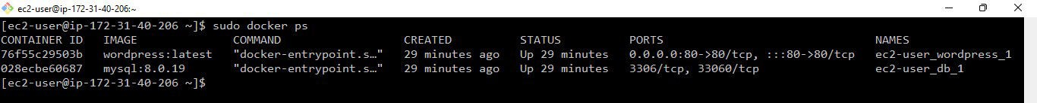

* And then lastly, I had a look to see that this was running correctly

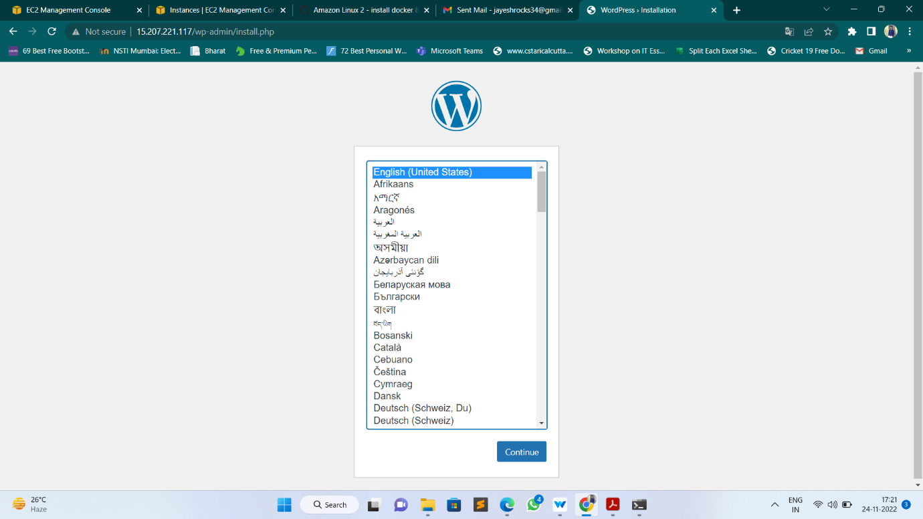

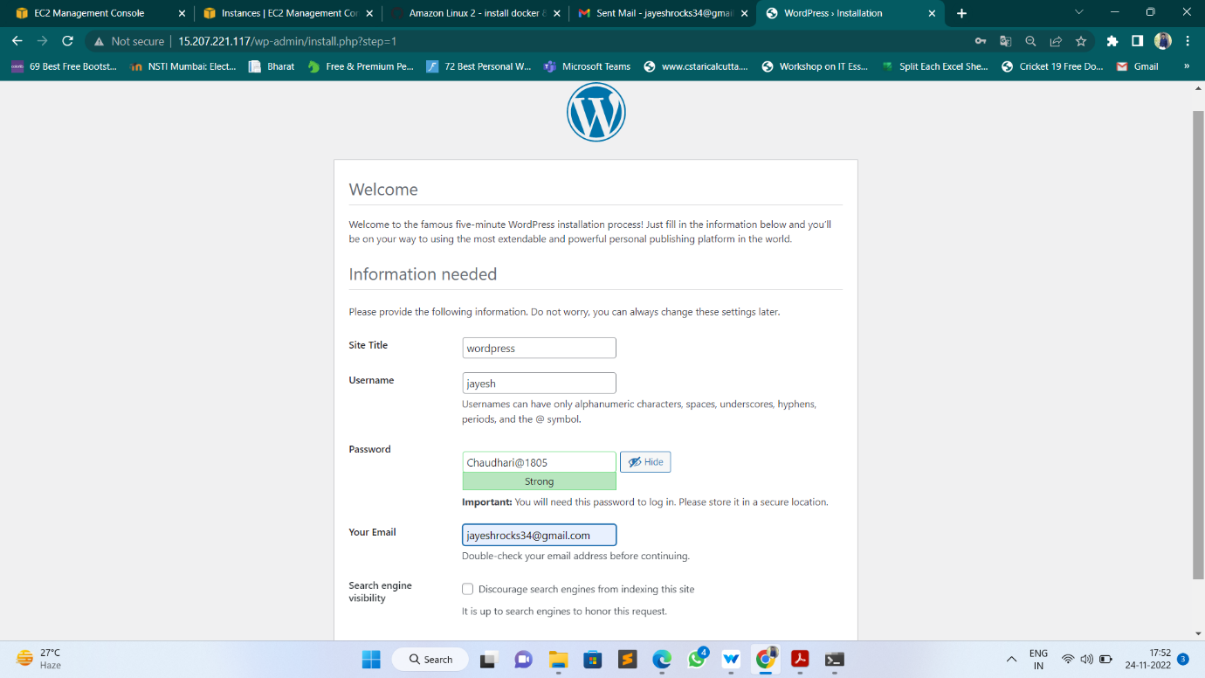

* This is the WordPress welcome page.

